Project Design Phase Solution Architecture

Date | 15 February 2025
Team ID | LTVIP2026TMIDS66228
Project Name | Advancing nutrition science through geminiai
Maximum Marks | 4 Marks

Solution Architecture:
Solution architecture for Advancing Nutrition Science through Gemini AI bridges the gap between user nutritional challenges and AI-powered technology solutions. It defines how the Streamlit web interface, Python backend, LangChain framework, Google Gemini API, and database components interact to deliver personalized meal plans, real-time nutritional insights, and virtual coaching. Its goals are to:

- Design an AI-powered nutrition system that effectively addresses personalized dietary management challenges.
- Describe the system structure, AI workflow, data processing, and user interaction to project stakeholders.
- Define core features such as nutritional analysis, meal planning, and AI-based virtual coaching.
- Provide technical specifications for development, deployment, scalability, and performance management.

Example - Solution Architecture Diagram:

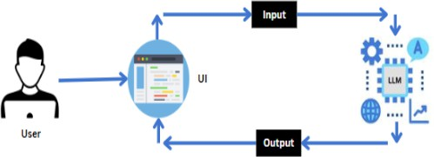

Figure 1: Architecture and Data Flow of the AI-Based Nutrition Assistant System Reference: https://c4model.com/

